Assignment – 3

1. Provide object-level security:
a. Verify that a user has permissions to see objects of a particular type.
b. Manage the object-level access through profiles and permission sets.

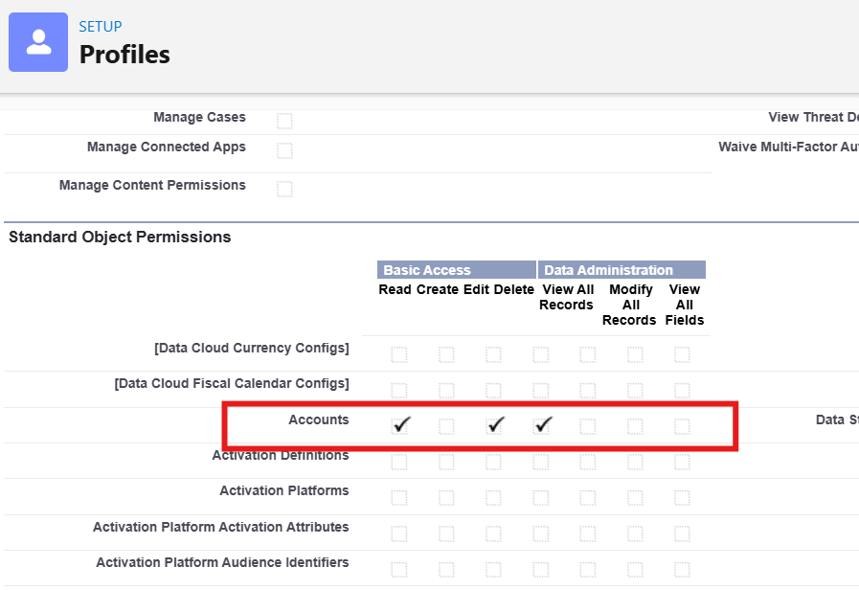

In Sam user account, no option to create a new record now as I have disabled the create option from Standard Object Permissions for that profile.

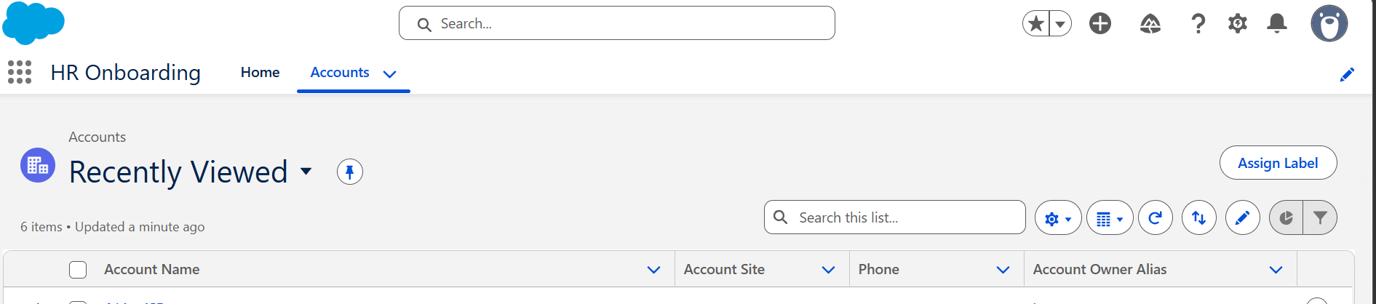
Now let us also check by enabling the create option from object level permissions from Sam profile.
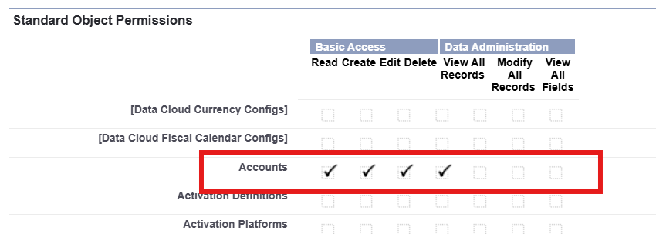
Now again we have an option to create a new record.
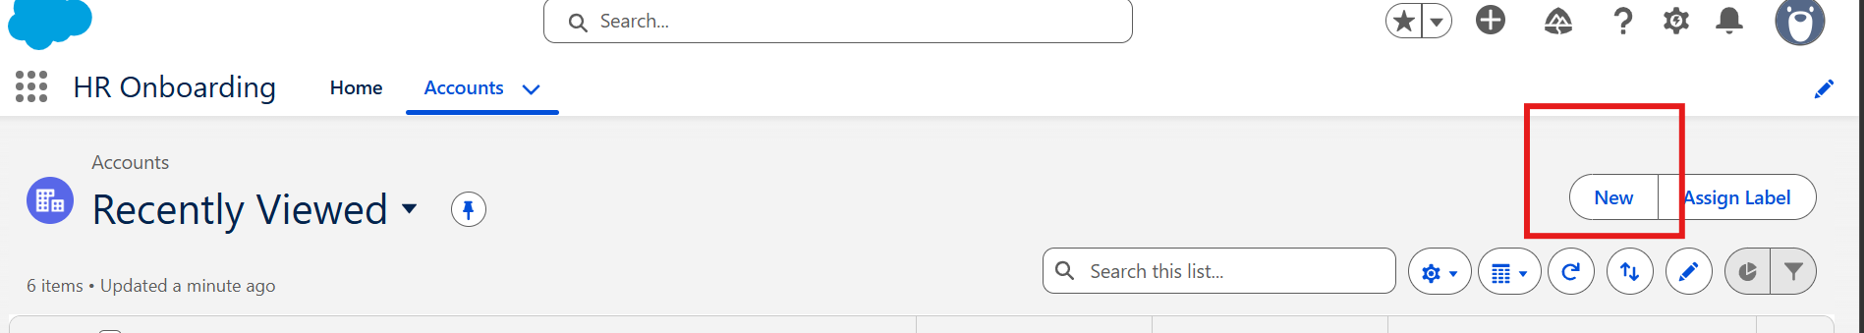

Permission Set:
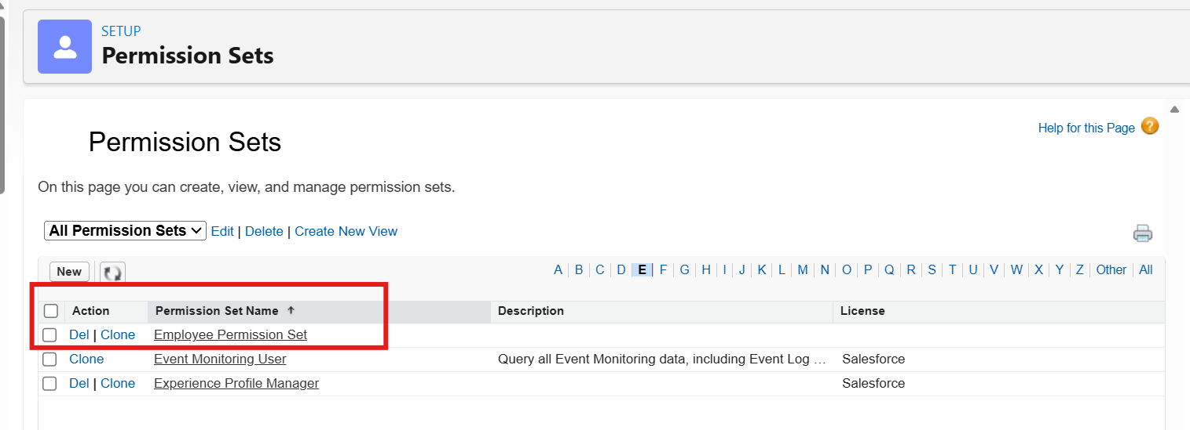
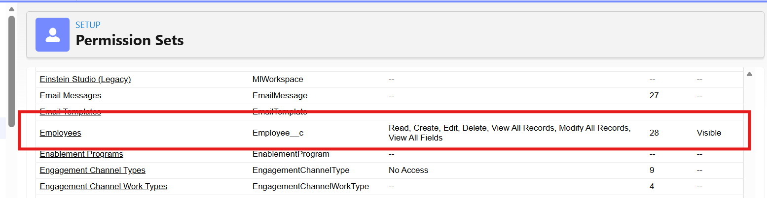
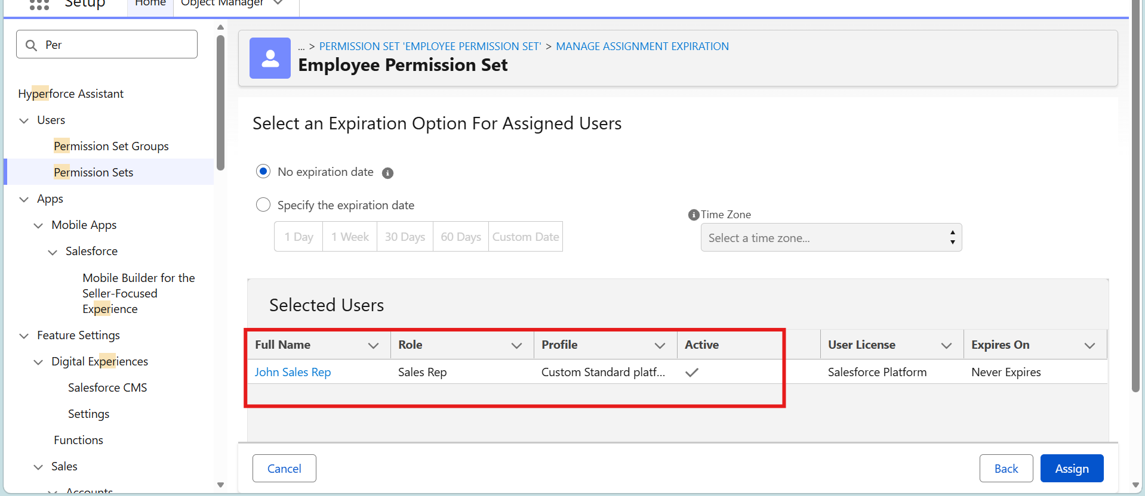
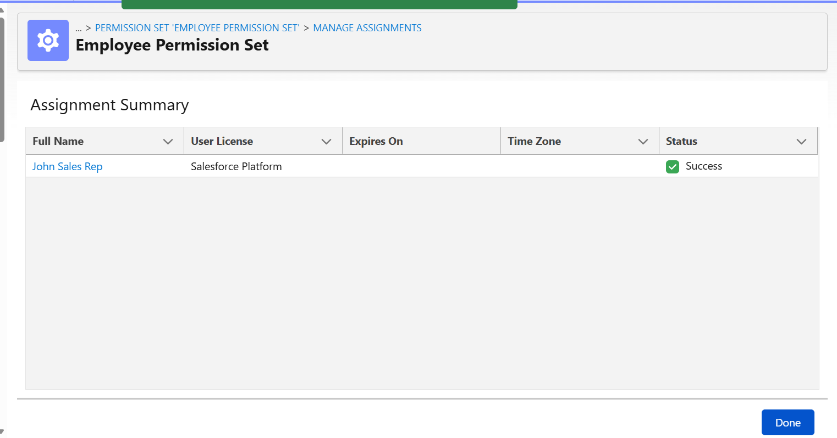
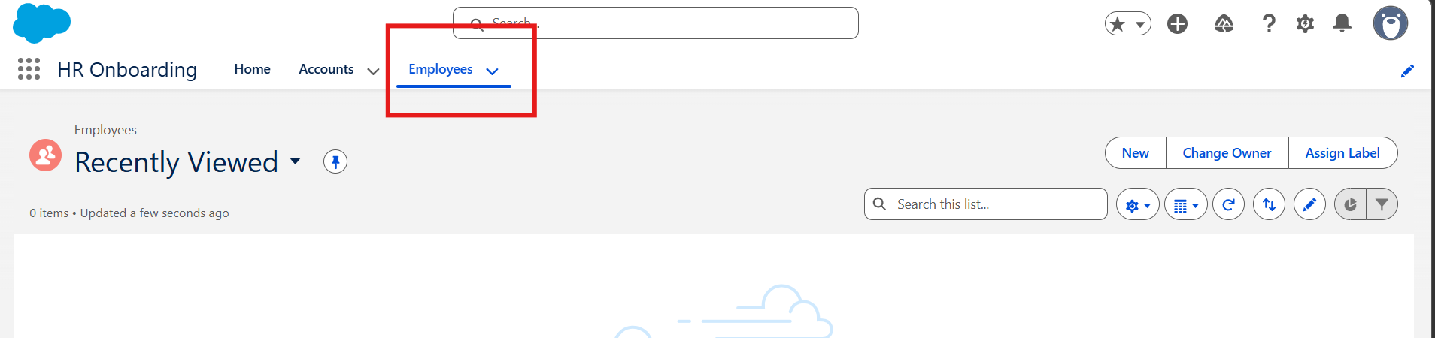

2. Even if Sam has access to objects, he still needs access to individual fields of each object. In Salesforce, profiles also control field-level access.
a. Provide field-level access to Sam.

Here I have removed access to edit the field, So in user profile account we cannot edit the field.
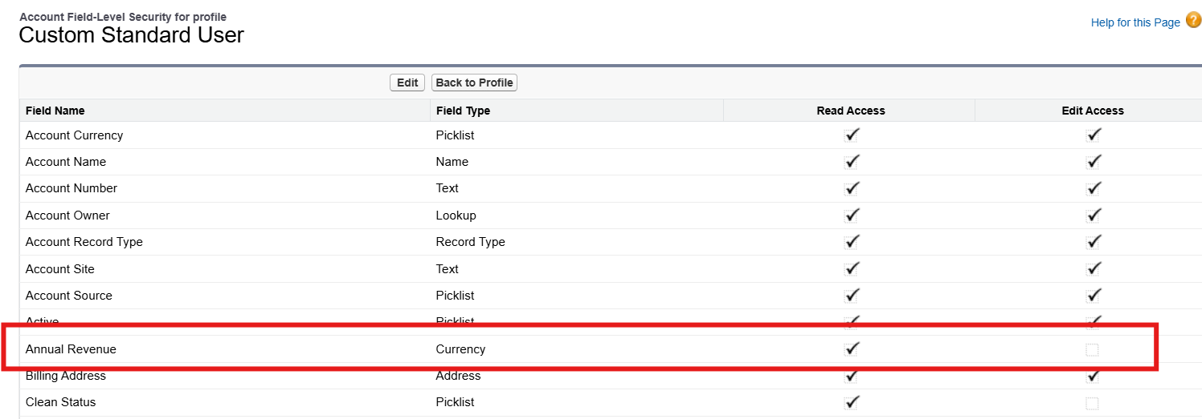

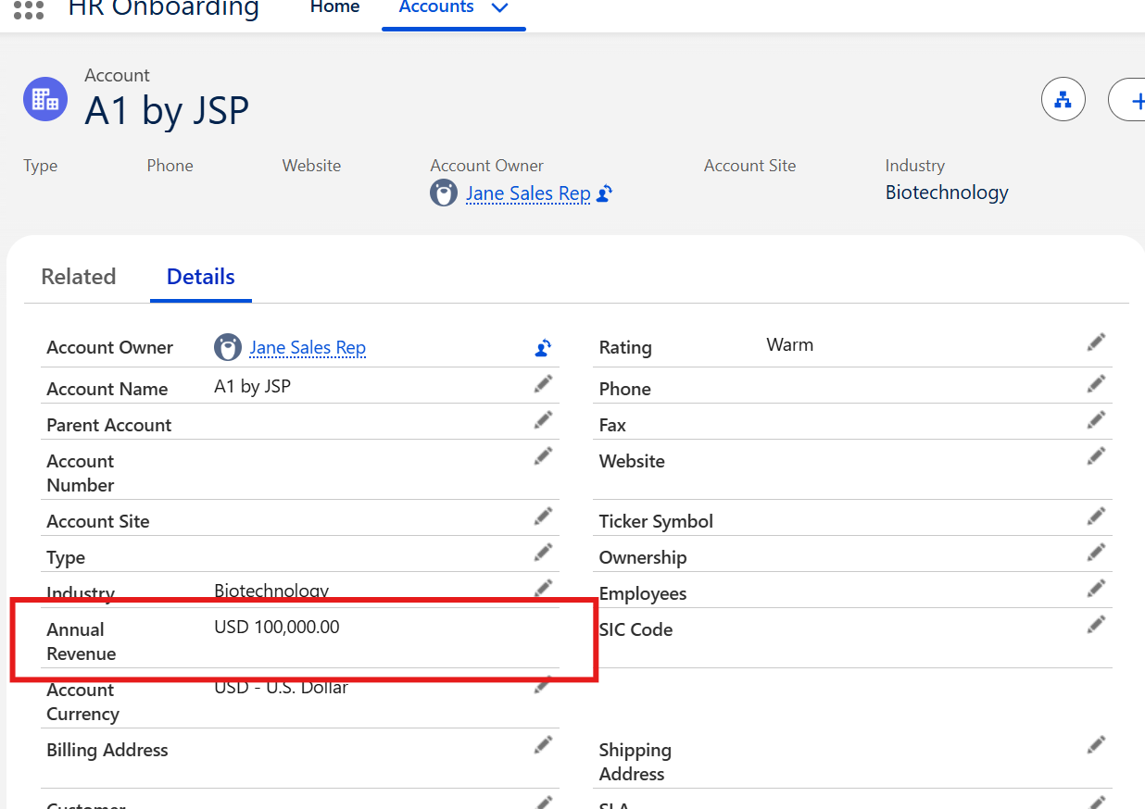

3. With just object-level access and field-level access, Sam can only access records he owns (i.e., records created by him).
a. If you look at the organizational structure, he reports to Zeck (the CEO), and he has two Sales Reps (Jane and John) reporting to him. Show the same.
b. Provide record-level security to Sam.
